Unit IV: Feature Engineering (6 Hours)
Feature Engineering is one of the most critical steps in Data Science and Machine Learning.
Feature Engineering is the process of transforming raw data (time-series, image, text, and categorical data) into meaningful inputs for machine learning models, improving prediction accuracy and model performance.

👉 Simple idea:
Better features → Better model performance

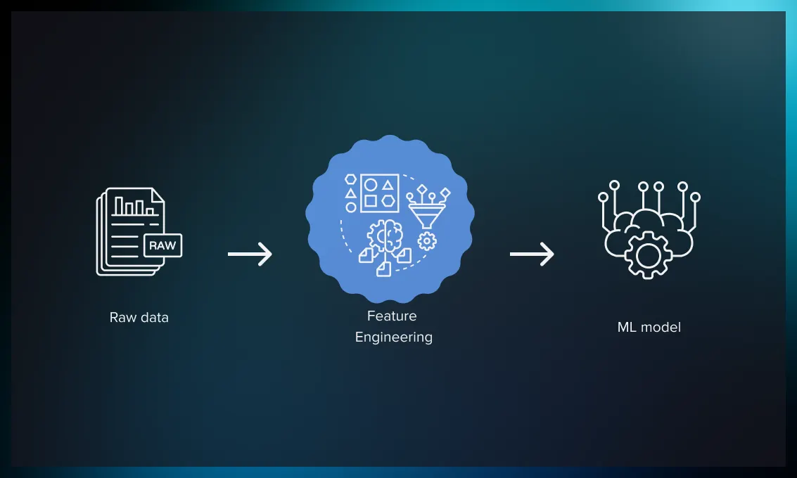

4.1 Types of Features
Different types of data require different feature engineering techniques.

1. Time-Series Features
Data collected over time intervals.
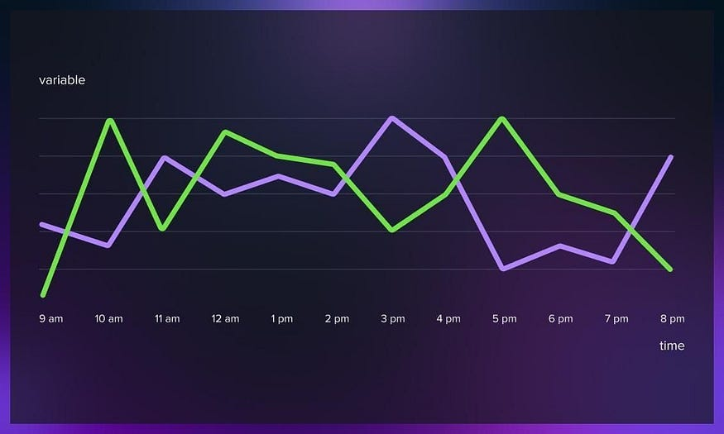

Examples:
- Stock prices
- Weather data
- Sales over time

Use Cases
- Forecasting (sales, weather)
- Trend analysis

Feature Engineering Techniques for Time-Series Data
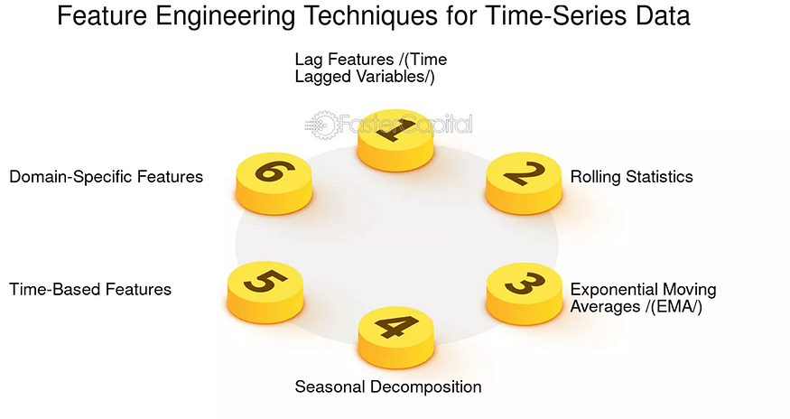
1. Lag Features
Lag features represent previous values of the time series.
In many real-world systems, the current value depends heavily on recent past values.
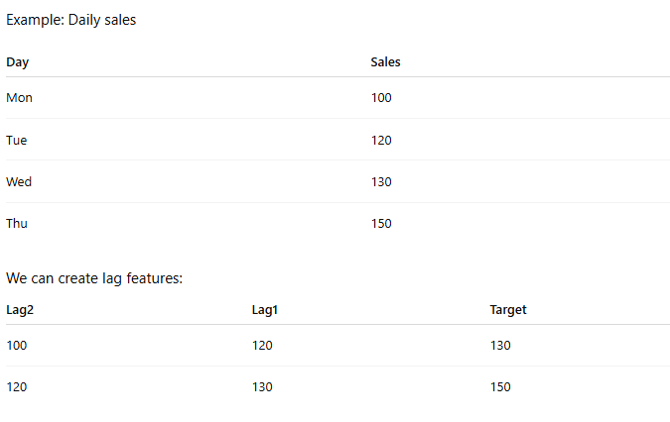
Explanation:
- Lag1 → previous value
- Lag2 → value two time steps ago

These past values become input features for the model.

Lag features allow models like XGBoost or Random Forest to learn temporal dependencies.

Example code using pandas:
data["lag1"] = data["sales"].shift(1)
data["lag2"] = data["sales"].shift(2)

2. Rolling Statistics
Lag features capture individual past values, but sometimes we want to capture short-term trends or averages.

This is where rolling statistics help.

Rolling statistics calculate metrics over a moving window of past observations.

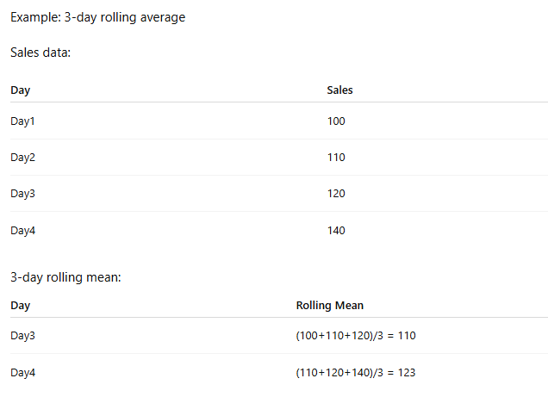

Rolling statistics help capture patterns such as:
- short-term trends
- volatility
- smoothing noisy data

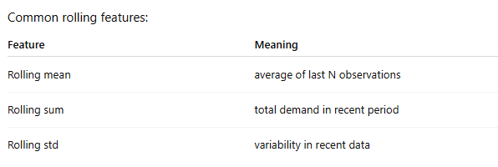

Example code:
data["rolling_mean_3"] = data["sales"].rolling(3).mean()
data["rolling_std_3"] = data["sales"].rolling(3).std()

These features help models understand recent behavior of the time series.

3. Date / Time Features
Time itself often contains useful patterns.

Certain events repeat depending on:
- day of the week
- month of the year
- time of day

So we can extract date-based features.
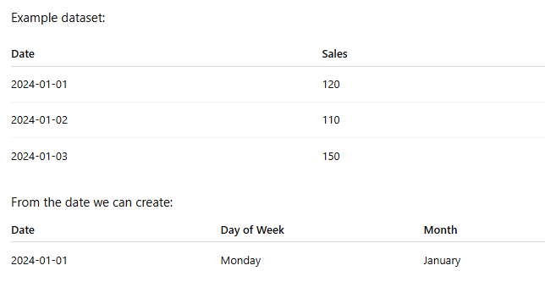
These features help models capture seasonality.

Example patterns:
- restaurants have higher sales on weekends
- e-commerce traffic increases during Christmas
- electricity demand increases in summer

Example feature extraction:
data["day_of_week"] = data["date"].dt.dayofweek
data["month"] = data["date"].dt.month

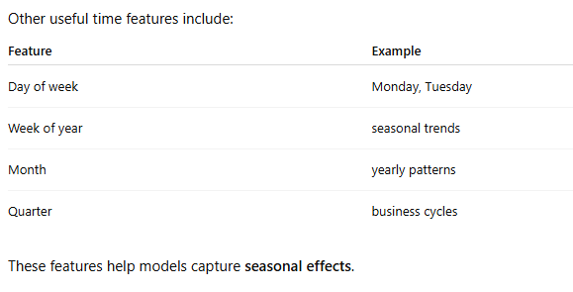

Other Feature Engineering Techniques
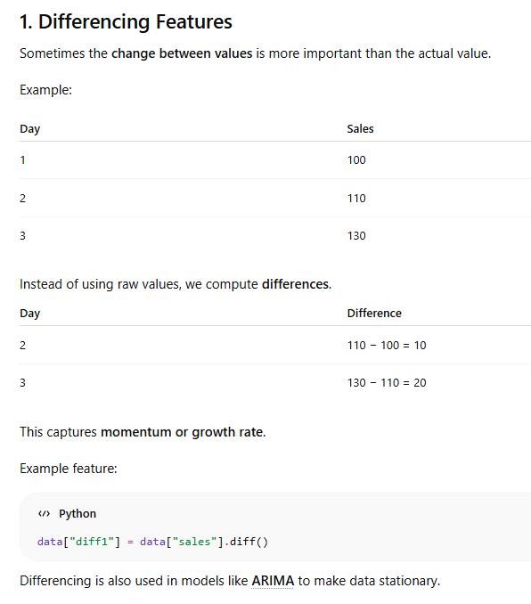
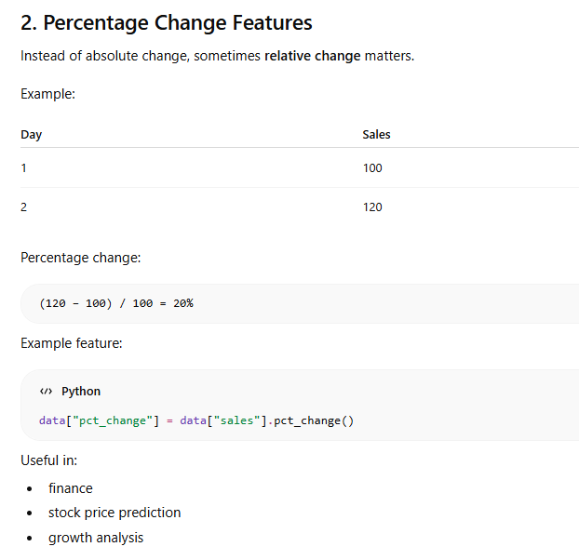
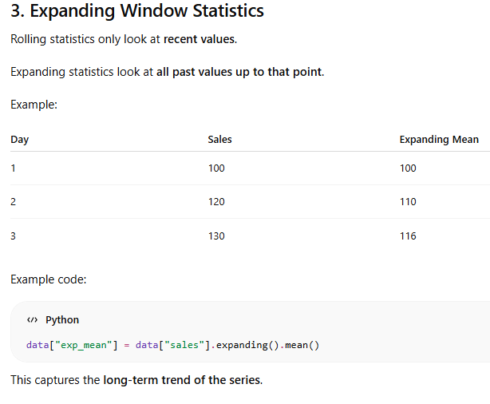
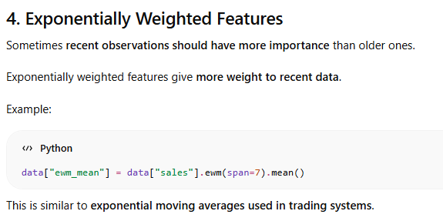

Roughly consider last 7 observations, but recent ones influence more
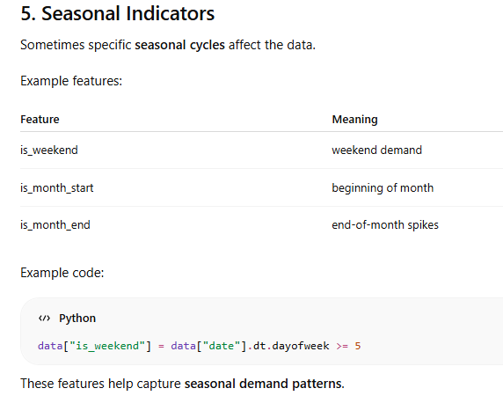


References:
- https://medium.com/@abhishekjainindore24/time-series-15-feature-engineering-059bea25478c
- https://www.linkedin.com/pulse/introduction-feature-engineering-time-series-duong-truong-kinic/
- https://medium.com/@rahulholla1/advanced-feature-engineering-for-time-series-data-5f00e3a8ad29
- https://www.analyticsvidhya.com/blog/2019/12/6-powerful-feature-engineering-techniques-time-series/
- https://www.geeksforgeeks.org/data-analysis/feature-engineering-for-time-series-data-methods-and-applications/

2. Image Features
Images are converted into numerical features.

Feature extraction means finding important information (features) from an image so a computer can understand it easily.

Instead of using every pixel, we extract useful patterns like:
- edges
- shapes
- colors
- textures
- corners
- objects

These features are mainly used in:
- Face recognition
- Object detection
- Medical imaging
- Self-driving cars
- OCR (text recognition)
- Machine Learning & Computer Vision

Feature extraction techniques in image processing
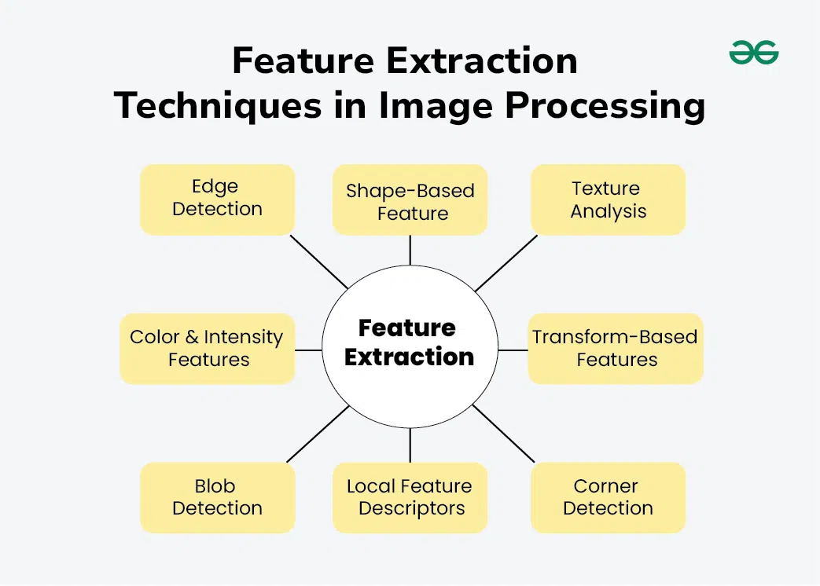

1. Color-Based Feature Extraction
This technique extracts information from image colors.

Common Methods
- RGB Histogram
- HSV Histogram
- Color Moments

Example
A mango image may contain:
- mostly yellow
- some green
The computer identifies the object using color distribution.

Applications
- Fruit classification
- Image search
- Product recognition

2. Edge Detection
Edges are boundaries of objects in an image.

Popular Edge Detection Techniques
- Sobel
- Prewitt
- Canny Edge Detector

Example
In a car image:
- wheels
- doors
- windows
can be identified from edges.

Advantages
- Helps identify object shape
- Reduces unnecessary data

3. Corner Detection
Corners are points where two edges meet.

Popular Methods
- Harris Corner Detector
- Shi-Tomasi Detector

Example
A chessboard has many corners, making it easy to detect.

Applications
- Motion tracking
- Object matching
- Robotics

4. Texture Feature Extraction
Texture describes surface patterns.

Common Techniques
- GLCM (Gray Level Co-occurrence Matrix)
- LBP (Local Binary Pattern)
- Gabor Filters

Example
- Brick wall → rough texture
- Water → smooth texture

Applications
- Medical image analysis
- Fingerprint recognition
- Surface inspection

5. Shape-Based Feature Extraction
This technique identifies object shapes.

Common Shape Features
- Area
- Perimeter
- Contours
- Circularity

Example
A coin can be detected because it is circular.

Applications
- Traffic sign recognition
- Object classification

6. SIFT (Scale-Invariant Feature Transform)
SIFT detects unique key points in an image.

Features
- Works even if image is:
  - rotated
  - scaled
  - partially changed

Applications
- Image stitching
- Object recognition

7. SURF (Speeded-Up Robust Features)
SURF is a faster version of SIFT.

Advantages
- Faster computation
- Good for real-time systems

Applications
- Augmented reality
- Real-time tracking

8. HOG (Histogram of Oriented Gradients)
HOG extracts edge direction information.

Working
It counts gradient directions in small image regions.

Applications
- Human detection
- Pedestrian detection

9. ORB (Oriented FAST and Rotated BRIEF)
ORB is fast and efficient for feature matching.

Advantages
- Faster than SIFT/SURF
- Open-source friendly

Applications
- Mobile vision apps
- Real-time object tracking

10. Deep Learning-Based Feature Extraction
Modern systems use deep neural networks to automatically learn features.

Popular CNN Models
- ResNet
- VGGNet
- AlexNet

Advantages
- Automatic feature learning
- Very high accuracy

Applications
- Face recognition
- Self-driving cars
- Medical diagnosis

Traditional vs Deep Learning Features
Traditional Methods | Deep Learning Methods
Handcrafted features | Automatically learned
Requires manual design | Learns from data
Less computational power | Requires GPU/training
Faster for small tasks | Better accuracy

Simple Real-Life Example
Imagine detecting a cat in an image.
The computer may use:
- Color → fur color
- Edge → body boundary
- Texture → fur pattern
- Shape → ears and face
- Deep learning → complete cat understanding

Summary Table
Technique | Extracts
Color Histogram | Color information
Edge Detection | Boundaries
Corner Detection | Intersection points
Texture Analysis | Surface patterns
Shape Features | Object geometry
SIFT/SURF | Key points
HOG | Gradient direction
ORB | Fast feature matching
CNN Features | High-level patterns

References:
- https://www.geeksforgeeks.org/computer-vision/feature-extraction-in-image-processing-techniques-and-applications/
- https://www.iotaacademy.in/post/the-role-of-feature-engineering-in-image-data
- https://towardsdatascience.com/feature-engineering-for-machine-learning-with-picture-data-d7ff8554920/

3. Text Features
Text data must be converted into numbers.

Computers cannot directly understand text like humans.
So, text data must be converted into numerical features before using it in Machine Learning or NLP (Natural Language Processing).

Applications
- Sentiment analysis
- Chatbots
- Spam detection

Techniques
1. Bag of Words (BoW)
Bag of Words is the simplest text feature extraction technique.
It counts how many times each word appears in a document.

Main Idea
- Ignore grammar
- Ignore word order
- Focus only on word frequency

Example
Sentence 1: "I love pizza"
Sentence 2: "I love burger"

Vocabulary:
Word | Sentence 1 | Sentence 2
I | 1 | 1
love | 1 | 1
pizza | 1 | 0
burger | 0 | 1

These counts become numerical features.

Advantages
- Simple
- Easy to implement
- Works well for basic tasks

Disadvantages
- Ignores context
- Ignores word order
- Large vocabulary size

2. TF-IDF (Term Frequency–Inverse Document Frequency)
TF-IDF improves Bag of Words by giving importance to meaningful words.

Common words like:
- the
- is
- and
get lower importance.

Rare but informative words get higher importance.

Formula
Term Frequency (TF)
Measures how often a word appears in a document.
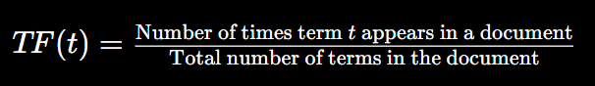

Inverse Document Frequency (IDF)
Measures how unique a word is across all documents.
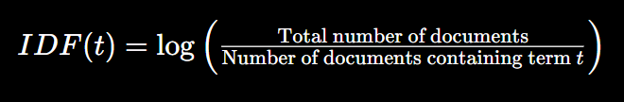

TF-IDF Score
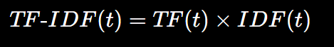

Example
If the word "machine" appears many times in one document but rarely in others, TF-IDF gives it a high score.

Advantages
- Better than BoW
- Reduces importance of common words
- Useful for document classification

Disadvantages
- Still ignores deep meaning
- Cannot fully understand context

3. N-Grams
N-Grams capture word sequence information.
Instead of looking at single words, it looks at groups of words.

Types of N-Grams
Type | Example
Unigram (1-word) | "I", "love", "pizza"
Bigram (2-word) | "I love", "love pizza"
Trigram (3-word) | "I love pizza"

Example
Sentence:
"New York is beautiful"

BoW
- New
- York
- beautiful

Bigram
- New York
- York is
- is beautiful

Now the model understands that "New York" is one meaningful phrase.

Advantages
- Captures local context
- Improves language understanding

Disadvantages
- Feature size increases rapidly
- Requires more memory

4. Word Embeddings (Dense Features)
Word embeddings convert words into dense numerical vectors.
Words with similar meanings are placed close together mathematically.

Popular Models
- Word2Vec
- GloVe
- FastText

Example
The model learns relationships like:

This means embeddings capture semantic meaning.

Simple Representation
Word | Vector
cat | [0.21, 0.45, 0.11]
dog | [0.19, 0.41, 0.10]

Since vectors are similar, the computer understands:
- cat and dog are related animals

Advantages
- Captures meaning and context
- Better performance in NLP
- Handles similarity well

Disadvantages
- Requires training data
- More computationally expensive

Comparison Table
Technique | Main Idea | Context Understanding
BoW | Word counts | Low
TF-IDF | Important word weighting | Low
N-Grams | Word sequences | Medium
Word Embeddings | Semantic meaning | High

Real-Life Example
Suppose emails contain:
"Congratulations! You won a lottery."

BoW
Detects words like:
- won
- lottery

TF-IDF
Finds rare suspicious words.

N-Grams
Detects phrases like:
- won lottery

Word Embeddings
Understands semantic similarity between:
- prize
- reward
- lottery
This helps spam detection systems work better.

References:
- https://apxml.com/courses/applied-data-science/chapter-2-practical-feature-engineering/text-feature-creation
- https://medium.com/@abdallahashraf90x/feature-engineering-in-nlp-a784d683bfce
- https://mylearningsinaiml.wordpress.com/ml-models/feature-engineering/feature-engineering-text-data/
- https://machinelearningmastery.com/7-feature-engineering-tricks-for-text-data/

4. Categorical Features
Data with categories (non-numeric)
Examples
- Gender
- Country
- Product type

Types of Categorical Features
- Nominal Features: Categories with no inherent ordering or ranking, such as city names, color, or item types.
- Ordinal Features: Categories that follow a logical order or ranking, such as small/medium/large or rating scales.
- High Cardinality Features: Categorical variables with a very high number of unique labels, such as user ID, product SKU, or zip code.

Categorical data must be converted to numbers.

Feature Engineering Techniques for Categorical Features:
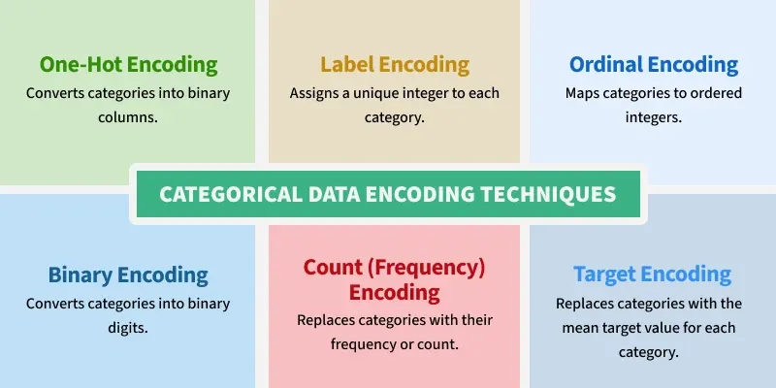

- One-Hot Encoding: Creates binary columns (0/1) for each category. Best for nominal data with low cardinality.
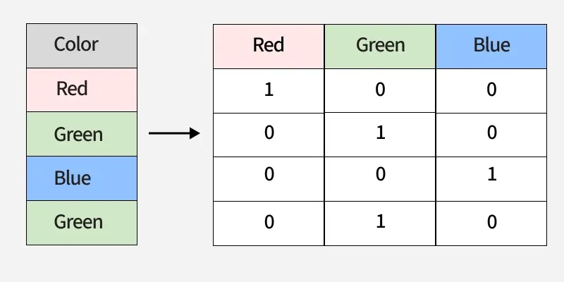
- Ordinal Encoding: Assigns a numerical integer to each category based on order (e.g., 1, 2, 3 for small, medium, large).
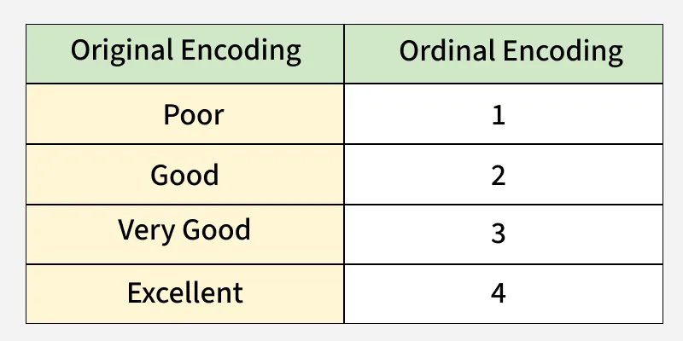
- Target Encoding (Mean Encoding): Replaces categories with the mean target value for that category. Effective for high-cardinality features but risks overfitting.
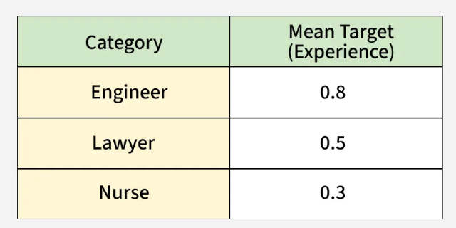
- Binary Encoding: Combines one-hot and hashing, reducing dimensionality while handling high-cardinality nominal data.
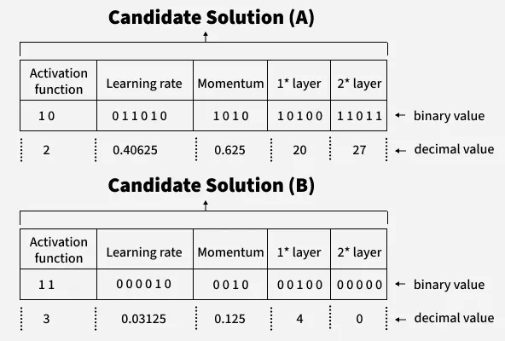
- Frequency/Count Encoding: Replaces categories with the number of times they appear in the dataset.
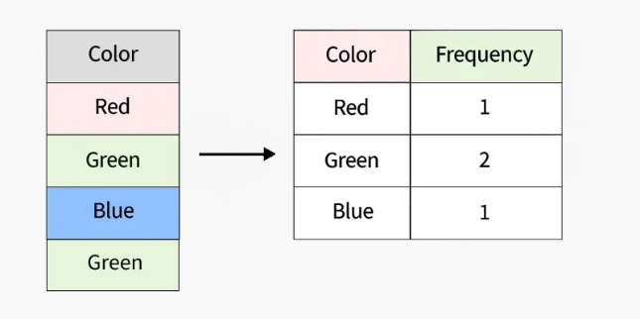
- Binning (Discretization): Converts numerical features into categorical features by grouping them into bins (e.g., transforming age into age groups).
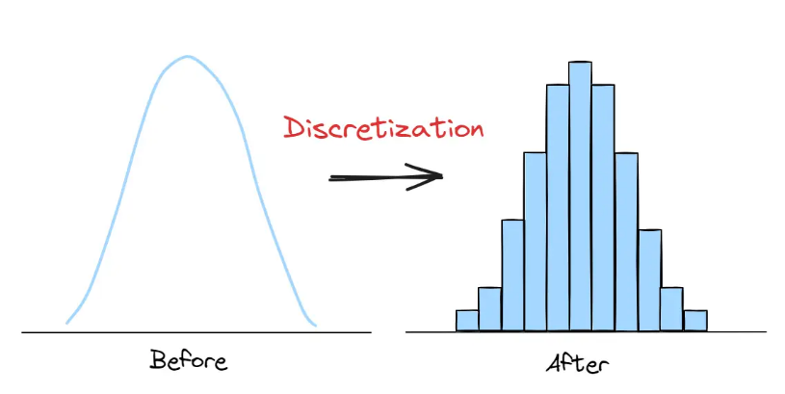

References:
- https://www.geeksforgeeks.org/machine-learning/categorical-data-encoding-techniques-in-machine-learning/
- https://medium.com/geekculture/feature-engineering-for-categorical-data-a77a04b3308
- https://www.kaggle.com/code/kenjee/categorical-feature-engineering-section-7-1

4.2 Feature Selection Techniques
Feature selection is the process of choosing the most relevant variables for training a machine learning model. Its primary goals are to improve predictive accuracy, reduce overfitting, speed up training times, and make models easier to interpret by removing redundant or noisy data.

1. Filter Methods
- Select features based on statistical measures
- Independent of ML models
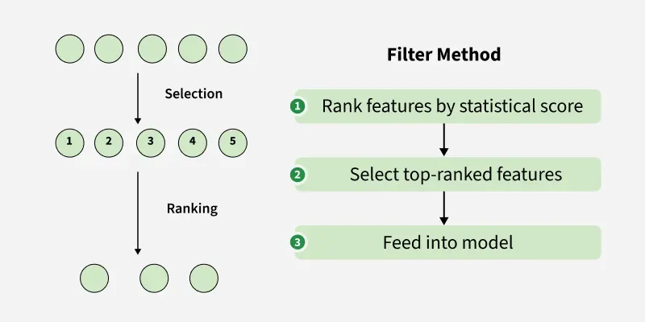

Techniques
- Correlation Matrix (Pearson Correlation): Identifies linear relationships between variables.
- Chi-Squared Test (χ2): Evaluates categorical variables' dependence on the target.
- Variance Threshold: Removes features with low variance (e.g., constant features).
- Information Gain/Mutual Information: Measures the reduction in entropy.

Advantages
- Fast and efficient: Filter methods are computationally inexpensive, making them ideal for large datasets.
- Easy to implement: These methods are often built-in to popular machine learning libraries, requiring minimal coding effort.
- Model Independence: Filter methods can be used with any type of machine learning model, making them versatile tools.

Limitations
- Limited interaction with the model: Since they operate independently, filter methods might miss data interactions that could be important for prediction.
- Choosing the right metric: Selecting the appropriate metric for our data and task is important for optimal performance.

2. Wrapper Methods
- Use ML models to evaluate features
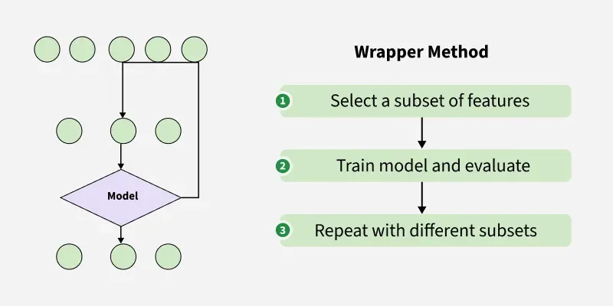

Techniques
- Forward Selection: Starts with no features and adds the most useful ones one by one.
- Backward Elimination: Starts with all features and removes the least useful ones one by one.
- Recursive Feature Elimination (RFE): Fits a model and recursively removes the weakest feature(s) until the best subset is reached.

Advantages
- Model-specific optimization: Wrapper methods directly consider how features influence the model, potentially leading to better performance compared to filter methods.
- Flexible: These methods can be adapted to various model types and evaluation metrics.

Limitations
- Computationally expensive: Evaluating different feature combinations can be time-consuming, especially for large datasets.
- Risk of overfitting: Fine-tuning features to a specific model can lead to an overfitted model that performs poorly on unseen data.

3. Embedded Methods
- Feature selection happens during model training
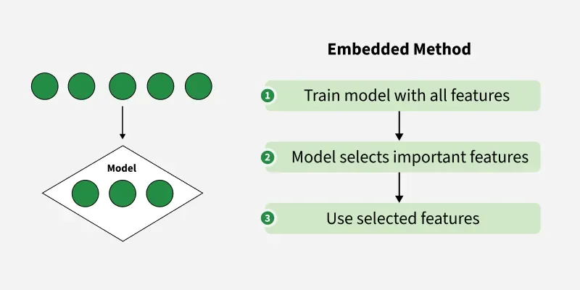

Examples
- LASSO (L1 Regularization): Forces coefficients of irrelevant features to zero, effectively selecting the best features.
- Tree-Based Selection: Decision trees (e.g., Random Forest) inherently assign feature importance, which can be used to rank features.

Advantages (Balanced approach (accuracy + speed))
- Efficient and effective: Embedded methods can achieve good results without the computational burden of some wrapper methods.
- Model-specific learning: Similar to wrapper methods these techniques uses the learning process to identify relevant features.

Limitations
- Limited interpretability: Embedded methods can be more challenging to interpret compared to filter methods making it harder to understand why specific features were chosen.
- Not universally applicable: Not all machine learning algorithms support embedded feature selection techniques.

References:
- https://www.geeksforgeeks.org/machine-learning/feature-selection-techniques-in-machine-learning/
- https://www.analyticsvidhya.com/blog/2020/10/feature-selection-techniques-in-machine-learning/
- https://medium.com/@nirajan_DataAnalyst/understanding-feature-selection-techniques-in-machine-learning-02e2642ef63e
- https://www.kaggle.com/code/piyushagni5/feature-selection-techniques-in-machine-learning
- https://papers.ssrn.com/sol3/papers.cfm?abstract_id=5154947

4.3 Data Reduction Techniques
Used to reduce the number of features while preserving important information.

A. Principal Component Analysis (PCA)
- Unsupervised technique.
- Finds new axes (principal components) that maximize variance.
- Components are o rthogonal (uncorrelated).
- Use when you want to reduce dimensions while retaining maximum information.

Steps:
- Standardize data (mean=0, variance=1).
- Compute covariance matrix.
- Eigen decomposition → select top components.
- Transform data.

Use Cases
- Image compression
- Noise reduction
- Visualization

PCA (Principal Component Analysis) is a dimensionality reduction technique and helps us to reduce the number of features in a dataset while keeping the most important information. It changes complex datasets by transforming correlated features into a smaller set of uncorrelated components.

It helps us to remove redundancy, improve computational efficiency and make data easier to visualize and analyze.

Steps to Perform PCA / How Principal Component Analysis Works
PCA uses linear algebra to transform data into new features called principal components. It finds these by calculating eigenvectors (directions) and eigenvalues (importance) from the covariance matrix. PCA selects the top components with the highest eigenvalues and projects the data onto them simplify the dataset.

Note: It prioritizes the directions where the data varies the most because more variation = more useful information.

Imagine you’re looking at a messy cloud of data points like stars in the sky and want to simplify it. PCA helps you find the "most important angles" to view this cloud so you don’t miss the big patterns. Here’s how it works step by step:
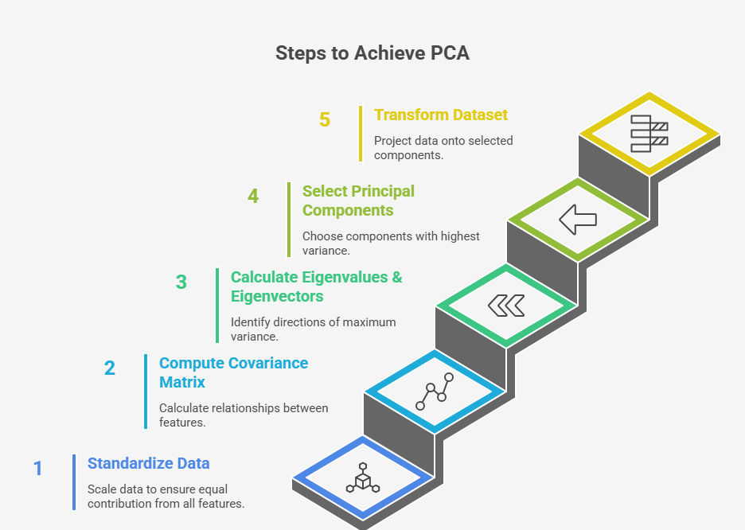

Step 1: Standardize the Data
Different features may have different units and scales like salary vs. age. To compare them fairly PCA first standardizes the data by making each feature have:
- A mean of 0
- A standard deviation of 1
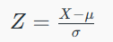
where:
- μ is the mean of independent features μ = {μ₁, μ₂, ⋯, μ_{m} }
- σ is the standard deviation of independent features σ = {σ₁, σ₂, ⋯, σ_{m}}

Step 2: Calculate Covariance Matrix
Next PCA calculates the covariance matrix to see how features relate to each other whether they increase or decrease together. The covariance between two features x₁​ and x₂​ is:
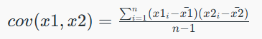
Where:
- and ​​ are the mean values of features x₁ and x₂
- n is the number of data points

The value of covariance can be positive, negative or zeros.

Step 3: Find the Principal Components
PCA identifies new axes where the data spreads out the most:
- 1st Principal Component (PC1): The direction of maximum variance (most spread).
- 2nd Principal Component (PC2): The next best direction, perpendicular to PC1 and so on.

These directions come from the eigenvectors of the covariance matrix and their importance is measured by eigenvalues. For a square matrix A an eigenvector X (a non-zero vector) and its corresponding eigenvalue λ satisfy:
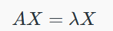

This means:
- When A acts on X it only stretches or shrinks X by the scalar λ.
- The direction of X remains unchanged hence eigenvectors define "stable directions" of A.

Eigenvalues help rank these directions by importance.

Step 4: Pick the Top Directions & Transform Data
After calculating the eigenvalues and eigenvectors PCA ranks them by the amount of information they capture. We then:
- Select the top k components that capture most of the variance like 95%.
- Transform the original dataset by projecting it onto these top components.

This means we reduce the number of features (dimensions) while keeping the important patterns in the data.
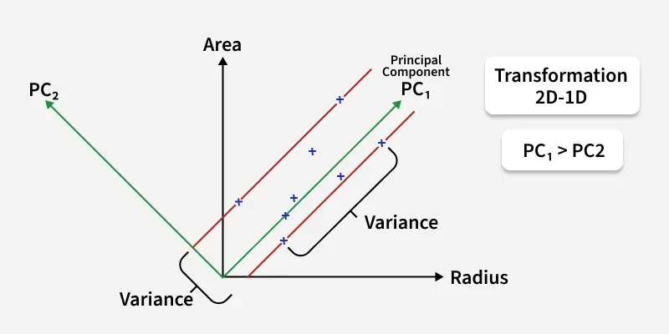
Transform this 2D dataset into a 1D representation while preserving as much variance as possible.
In the above image the original dataset has two features "Radius" and "Area" represented by the black axes. PCA identifies two new directions: PC₁ and PC₂ which are the principal components.
- These new axes are rotated versions of the original ones. PC₁ captures the maximum variance in the data meaning it holds the most information while PC₂ captures the remaining variance and is perpendicular to PC₁.
- The spread of data is much wider along PC₁ than along PC₂. This is why PC₁ is chosen for dimensionality reduction. By projecting the data points (blue crosses) onto PC₁ we effectively transform the 2D data into 1D and retain most of the important structure and patterns.

References:
- https://www.geeksforgeeks.org/data-analysis/principal-component-analysis-pca/
- https://medium.com/analytics-vidhya/understanding-principle-component-analysis-pca-step-by-step-e7a4bb4031d9
- https://ashutoshtripathi.com/2019/07/11/a-complete-guide-to-principal-component-analysis-pca-in-machine-learning/
- https://www.upgrad.com/blog/pca-in-machine-learning/

B. Linear Discriminant Analysis (LDA)
LDA is used for dimensionality reduction + classification
- Supervised technique.
- Finds axes that maximize separation between classes (maximizes between-class variance, minimizes within-class variance).
- Used mainly for classification problems.
- Number of components ≤ (number of classes - 1).

Applications
- Face recognition
- Pattern classification

Linear Discriminant Analysis (LDA) is a supervised learning technique used for classification tasks. It helps distinguish between different classes by projecting data points onto a lower-dimensional space, maximizing the separation between those classes.
LDA performs two key roles:
- Classification: It finds a linear combination of features that best separates multiple classes.
- Dimensionality Reduction: It reduces the number of input features while preserving the information necessary for classification.

Mathematical Core Idea
LDA identifies a new axis (or set of axes) that provides optimal class separability. To achieve this, it maximizes Fisher's criterion, which is the ratio of between-class variance to within-class variance:
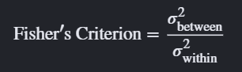
For two classes with means μ₁, μ₂ and variances S₁², S₂² after projection, the objective is to maximize the following ratio:
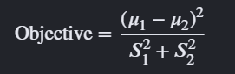

For example, in a dataset where each data point belongs to one of three classes, LDA transforms the data into a space where the classes are well-separated, making it easier for models to classify them correctly.
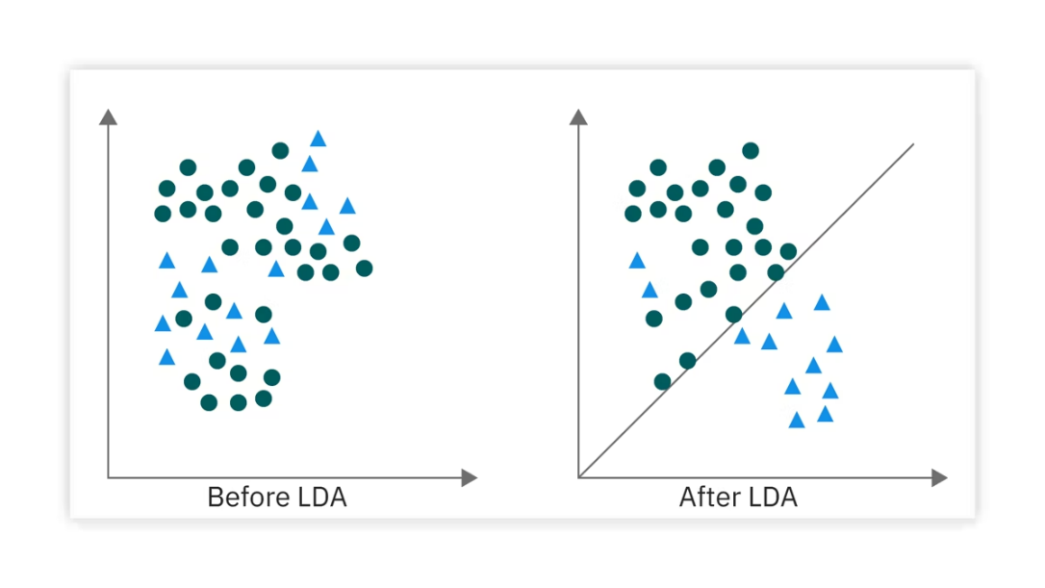

Step-by-Step Algorithm
- Compute Class Statistics: Calculate the mean vector for each independent class and the global mean vector across the entire dataset.
- Class mean
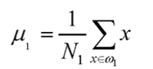

- Construct Scatter Matrices:
  - Within-class scatter matrix (S_{W}): Quantifies the internal spread or variance pooled across all classes.
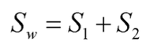

Where,
- Covariance matrix
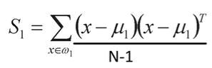

  - Between-class scatter matrix (S_{B}): Measures how far apart individual class means are from the global mean.
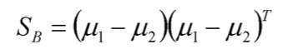

- Eigenvalue Decomposition: Solve the generalized eigenvalue problem to find the optimal projection vectors (w):
    - eigenvalue
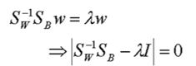

- Project Data: Sort the resulting eigenvectors by their corresponding eigenvalues λ in descending order. Select the top eigenvectors to form a transformation matrix, and project the original data points into this lower-dimensional subspace.
    - Eigen vector
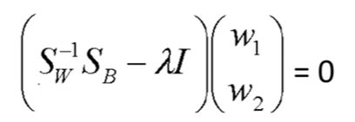

Or direct method (straight forward method):
If you follow this formula, you don’t need to calculate eigenvalue and eigenvector
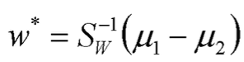

Questions:
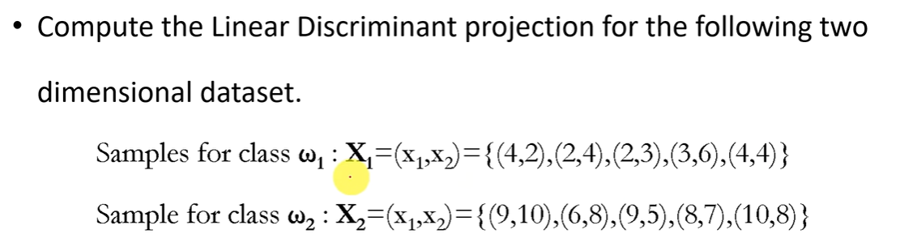

References:
  - https://www.geeksforgeeks.org/machine-learning/ml-linear-discriminant-analysis/
  - https://www.appliedaicourse.com/blog/linear-discriminant-analysis-in-machine-learning/
  - https://medium.com/data-science/linear-discriminant-analysis-lda-598d8e90f8b9
  - https://www.kaggle.com/code/egazakharenko/linear-discriminant-analysis-lda-from-scratch
  - https://web.stanford.edu/class/stats202/notes/Classification/LDA.html

PCA vs LDA:
- PCA: Unsupervised, maximizes variance (good for compression).
- LDA: Supervised, maximizes class separability (better for classification).

Feature | PCA (Principal Component Analysis) | LDA (Linear Discriminant Analysis)
Primary Goal | Finds axes of maximum variance | Finds axes that maximize the separation between classes
Supervision | Unsupervised (ignores labels) | Supervised (requires labels)
Objective | Projects data to keep as much overall information as possible | Projects data to make distinct groups as distinguishable as possible
Use Case | Data preprocessing, noise reduction, and visualization | Feature selection and preprocessing specifically for classification models
Key Constraint | New components are completely orthogonal (uncorrelated) | Limited by C - 1 components (where C is the number of classes)
Data Assumptions | Data must be continuous | Assumes normally distributed data and equal class covariances

Possible Exam Questions
Short Questions (2–3 Marks)
- Define feature engineering
- What is one-hot encoding?
- What is PCA?
- Define filter method

Long Questions (5 Marks)
- Explain types of features with examples
- Discuss feature selection techniques
- Differentiate PCA and LDA
- Explain dimensionality reduction techniques

